

American International University-Bangladesh (AIUB)

**Department of Computer Science Faculty of Science &Technology (FST) Summer 22 23**

**BloodBond – A Blood Donation and Community System**

Software Requirement Engineering Sec: **A**

Project submitted

By

Shahrier Hossain (19-41628-3)

Md. Shakibur Rahman (20-42723-1) Rashida Begum Lima (20-44095-2) NurMohammad(20-42633-1)

# Checked By Industry Personnel

Name: A K M Ehsanul Haque

Designation: Head of Business Intelligence & Revenue Assurance Company: PayWell

Sign:

Date: 14 August 2023

Table of Contents

1. PROBLEM DOMAIN 3
   1. Background to the Problem 3
   2. Solution to the problem 4
2. SOLUTION DESCRIPTION 5
   1. System Features 5
   2. UML Diagrams 9
      1. Activity Diagrams 9
      2. E-R Diagrams 10
      3. use-case Diagrams 11
3. Social Impact 12
4. Development Plan with Project Schedule 14
5. Marketing Plan 15
6. Cost and Profit Analysis 16
7. Reference 16

# PROBLEM DOMAIN

# Background to the Problem

Introducing "Blood Bond" - Revolutionizing Blood Donation Through Connectivity and Compassion. The accessibility and availability of blood donations play a crucial role in saving lives in a world where medical emergencies and healthcare requirements are constant. However, the current systems for blood donation and distribution often fall short of meeting the changing needs of our society and are inefficient.

Blood donation has long been an essential part of healthcare, allowing doctors to carry out life-saving operations, surgeries, and therapies. But there have been problems with the traditional procedure. Due to irregular donations, local blood banks find it difficult to keep proper blood reserves, which causes severe shortages during emergencies. Finding proper donation facilities and getting prompt information about urgent needs are frequent challenges for donors. Furthermore, a fragmented and ineffective blood delivery network was created due to the absence of a uniform platform for donors, recipients, and healthcare organizations.

To close gaps and remove the obstacles that blocked effective blood donation and distribution, the "Blood Bond" project was set up. The campaign looks to transform how we think about blood donation by using the power of technology, networking, and the basic principles of kindness.

**Project Vision and Scope:** "Blood Bond" imagines a world in which everybody, no matter where they live or what their circumstances are, may contribute to and gain from a network of connected blood donation systems. The software will act as a reliable, user-friendly platform that enables direct communication between blood donors, those who need blood, and healthcare organizations.

Users of this platform will be able to:

**Donate Anytime, anywhere:** Donors can easily find nearby blood donation centers, mobile blood drives, and community events, making the act of donating blood more accessible and convenient.

**Real-time Alerts:** Recipients and medical facilities can post urgent blood requirements in real time, triggering immediate notifications to nearby donors who match the needed blood type and eligibility criteria.

**Personalized Profiles:** Donors can create profiles detailing their blood type, availability, and donation history. This information helps in efficient matching during emergencies.

**Community Engagement:** The platform fosters a sense of community by allowing users to share their donation experiences, success stories, and support for those in need.

"Blood Bond" transforms the act of donating blood into an inspiring and accessible work, uniting various individuals under a similar goal: to save lives, one drop at a time, in this shared vision of connectivity, convenience, and humanity.

**Root Cause:** Lack of Efficient Blood Donation Infrastructure and Information Flow

The absence of an effective infrastructure and streamlined information flow is the primary contributor to the difficulties met in the environment surrounding blood donation. This can be ascribed to several connected causes, including:

**Inadequate Communication:** Traditional methods of communication between blood banks, medical facilities, donors, and recipients are often slow and cumbersome. This leads to delays in matching blood supply with demand, particularly during emergencies.

**Limited Accessibility:** Many potential donors are unaware of nearby blood donation centers or events, leading to missed opportunities for contributions. Conversely, recipients may struggle to find available donors during critical times.

Importance of Addressing the Problem:

The problem of inefficient blood donation and distribution is of paramount importance for several reasons:

**Medical Progress:** Advances in medical treatments, organ transplants, and surgeries are heavily reliant on a consistent and well-managed blood supply. Any disruption can have a cascading effect on various healthcare procedures.

**Donor Engagement:** A well-connected platform enhances donor engagement, recognizing their contributions and fostering a sense of belonging to a larger community that saves lives.

# Solution to the Problem

The solution offers a range of features to address the root causes of the problem:

**Real-Time Connectivity:** The application supplies real-time connectivity between donors, recipients, and medical facilities. Donors receive instant alerts about urgent blood requirements, ensuring prompt responses and addressing supply-demand mismatches.

**Locational Services:** "Blood Bond" employs geolocation services to help users find nearby blood donation centers, mobile drives, and events. This accessibility increases the likelihood of donors taking part in blood donation campaigns.

**Personalized Profiles**: Donors can create profiles detailing their blood type, availability, and donation history. This data is essential for efficient matching during emergencies, reducing communication delays and administrative hurdles.

**Community Engagement:** The platform fosters a sense of community by allowing users to share their donation experiences, stories, and support for those in need. This engagement strengthens the emotional connection between donors and recipients.

**User-Friendly Interface:** The application's intuitive interface ensures that users of all ages and technological backgrounds can easily navigate and use its features.

Appropriateness of the Solution:

## Feasibility and Business Objectives:

The solution is highly possible and aligns well with the business aims of the "Blood Bond" project. The integration of existing technologies such as mobile apps, geolocation services, and data analytics is well-established, reducing the implementation challenges. The success of similar applications in other domains (e.g., ride-sharing apps) proves the feasibility of creating a user-friendly platform for real-time interactions.

# SOLUTION DESCRIPTION

# System Features

## The software has quick search for blood features.

* + - **Live location of a donor or patient feature.**

## Integrated Google map and on-demand GPS system.

* + - **“Become a donor” feature with simple donor registration feature.**

## Quick connectivity between donors and patients.

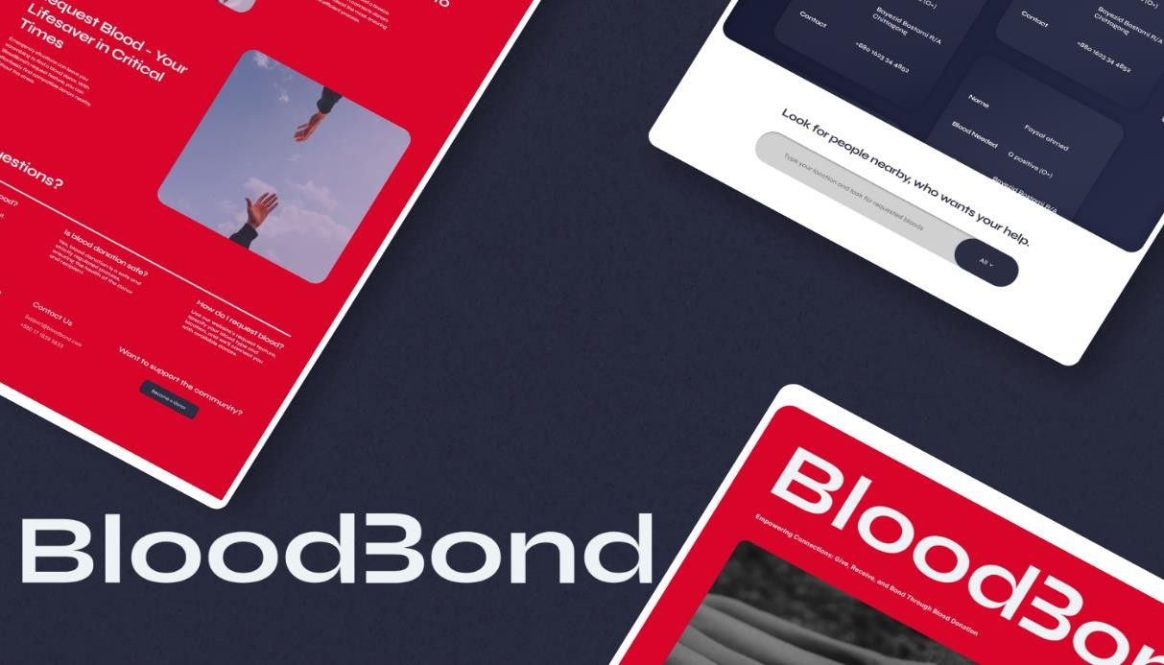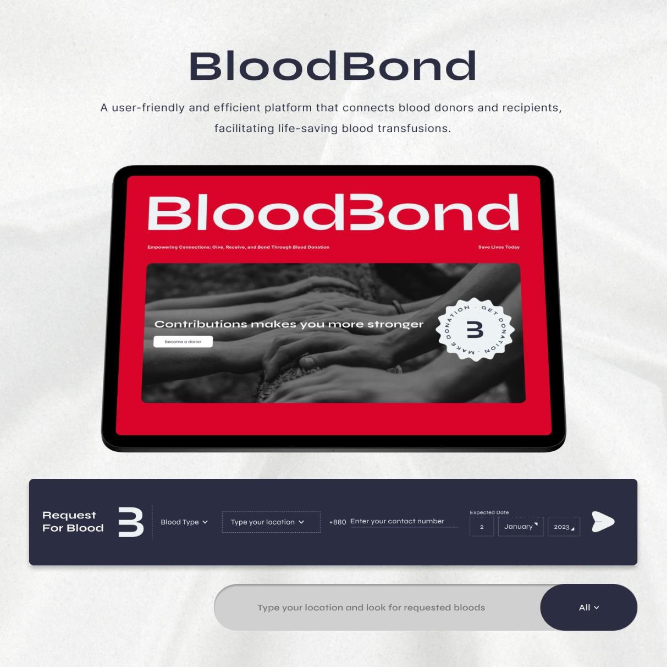

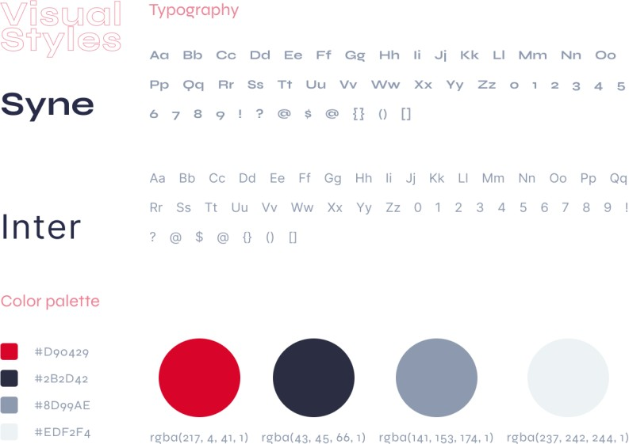

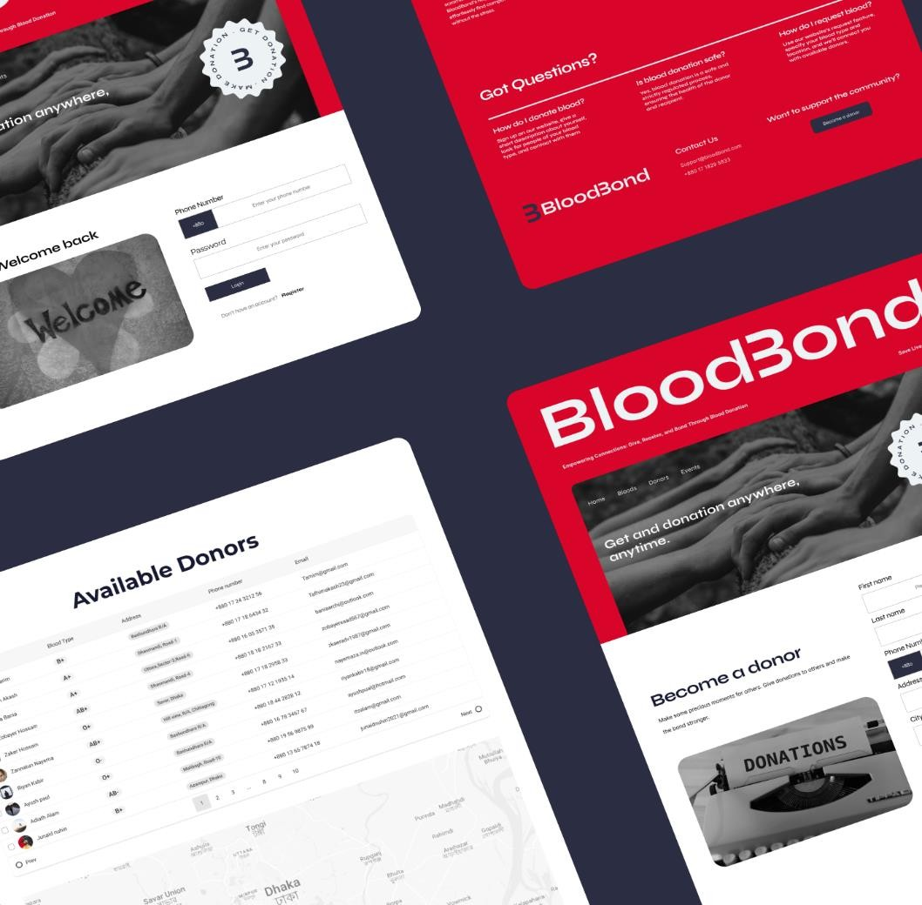

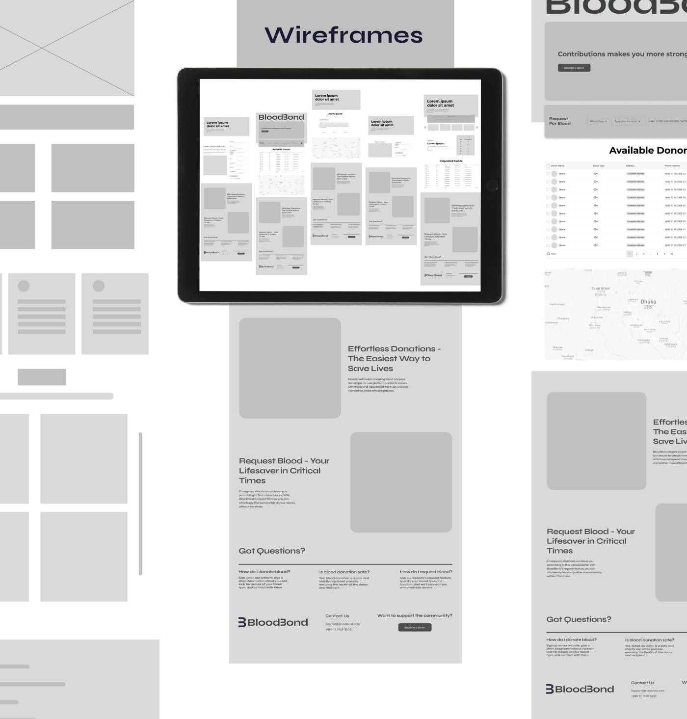

**Project Name: Blood Bond Project link:** [Figma Prototype](https://www.figma.com/proto/DeEQsxdAthuhyXIW5m0vsJ/BloodBond?page-id=0%3A1&type=design&node-id=28-1688&viewport=-632%2C211%2C0.18&t=VdtWF3MaUTCdhIWL-1&scaling=scale-down&starting-point-node-id=9%3A126&mode=design)

# UML DIAGRAMS

* + 1. 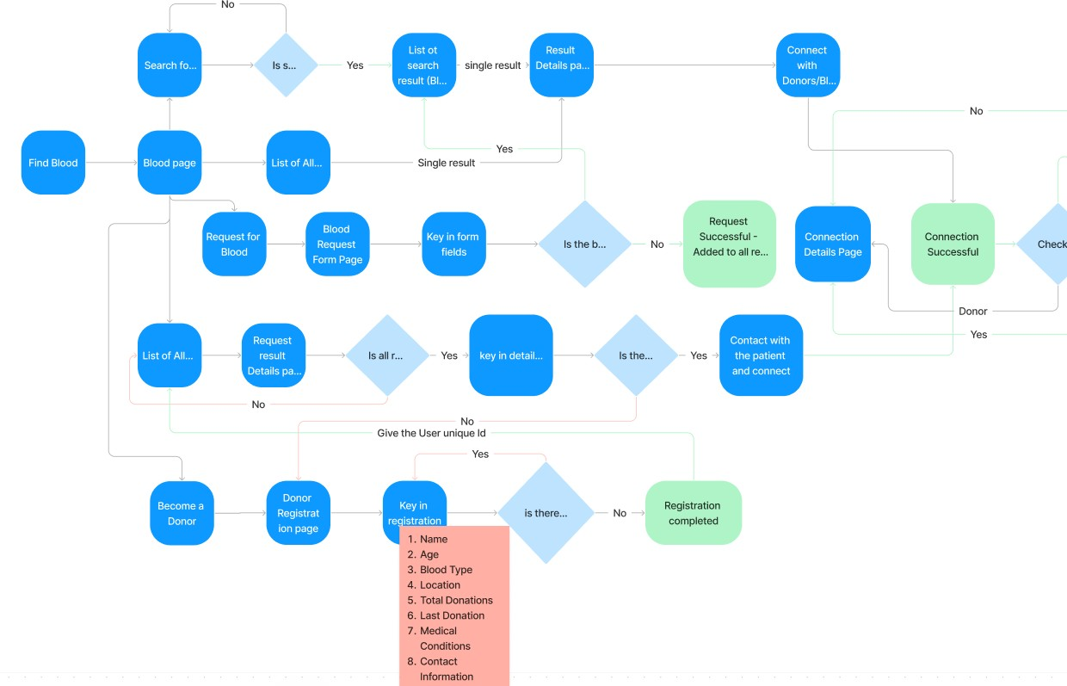**Activity diagram**

# E-R Diagram

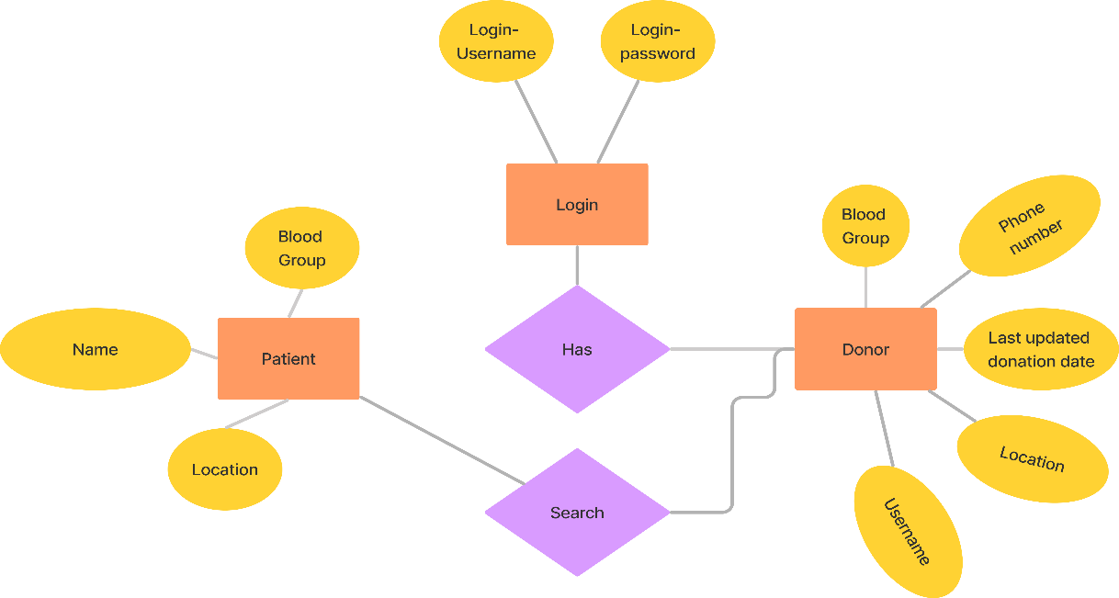

* + 1. **Use-Case Diagram**

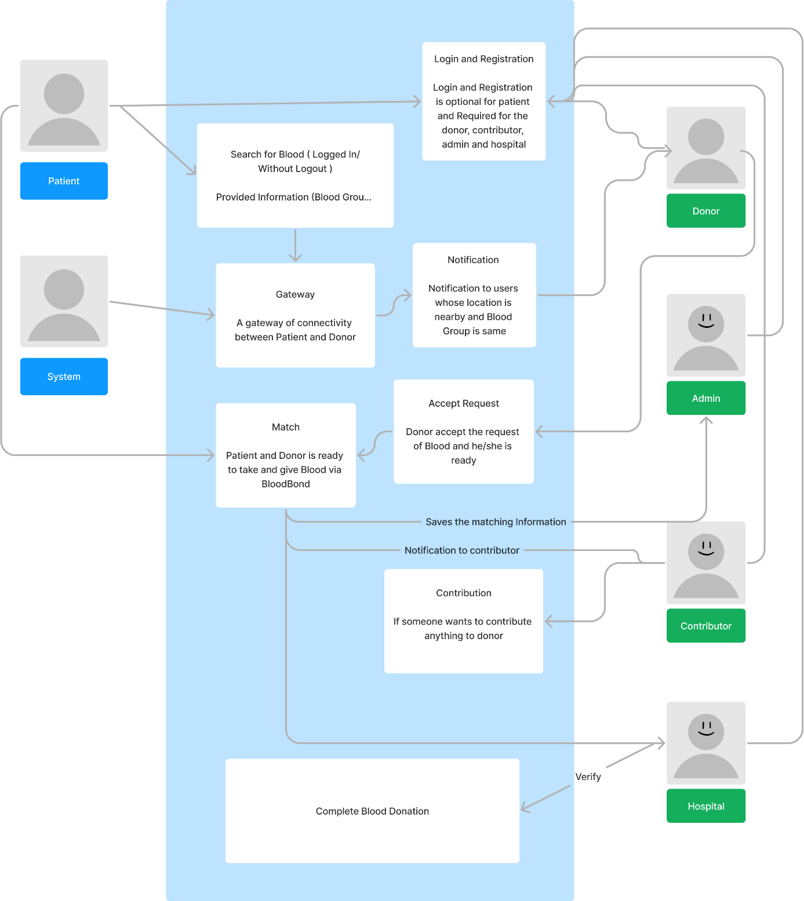

# Social Impact

The Blood Donation and Community System is a transformative initiative poised to bring profound benefits to society. By streamlining the blood donation process, the system ensures a readily available supply of blood for emergencies, surgeries, and treatments, directly translating to saved lives and improved medical outcomes. Swift response to crises and disasters is assured, minimizing shortages and ensuring prompt patient care.

Beyond its life-saving impact, the system cultivates a sense of community engagement and responsibility. Regular blood donation has become a cultural norm, fostering connections and compassion among individuals. This shared commitment strengthens community bonds, promoting public health and resilience.

The system's educational platform dispels myths and raises awareness about blood donation, empowering potential donors with correct information. Data-driven insights inform healthcare planning, perfecting strategies for effective blood collection and distribution.

Moreover, the project encourages partnerships among healthcare institutions, non-profits, and volunteers, amplifying its positive effects.

# Development Plan with Project Schedule

**Process Model:**

Our process model proves how effectively the agile method matches the needs of our project. The agile method aids in the quickest possible delivery of features. The development method also updates the client on the status of the project. Thanks to ongoing communication between the software team and stakeholders, we can respond to comments quickly. With essence, it aids with requirement validation. Again, because agile development methodologies promote customer involvement, the incremental process model reduces risk. This enables a more realistic perspective of the demands and the development of the improvement.

**Task List**

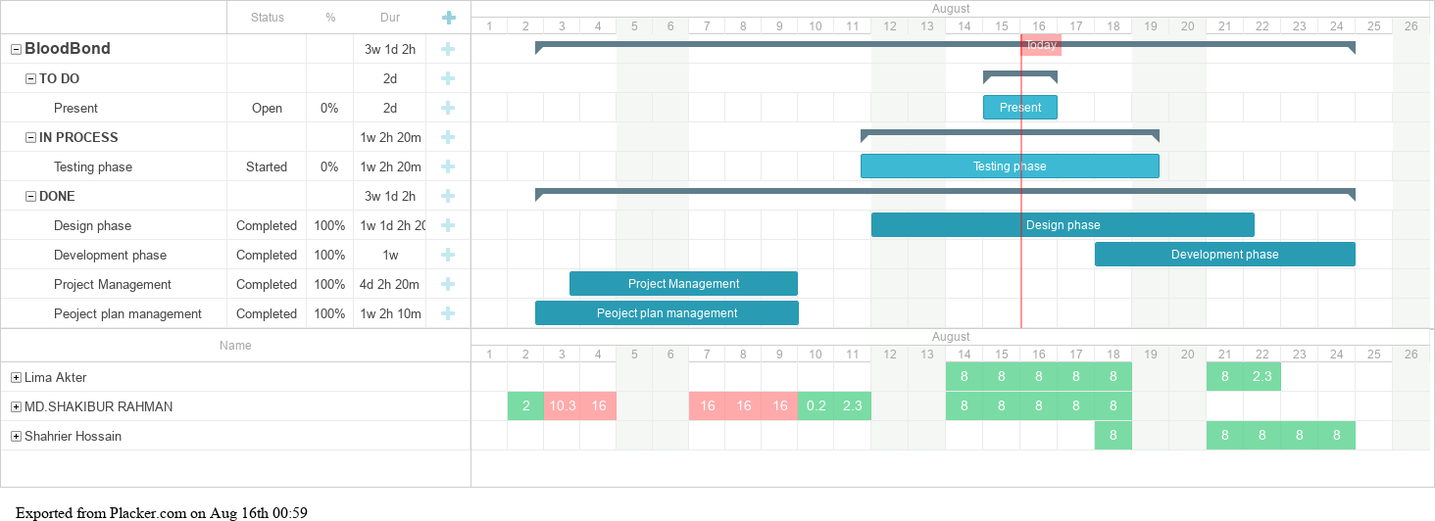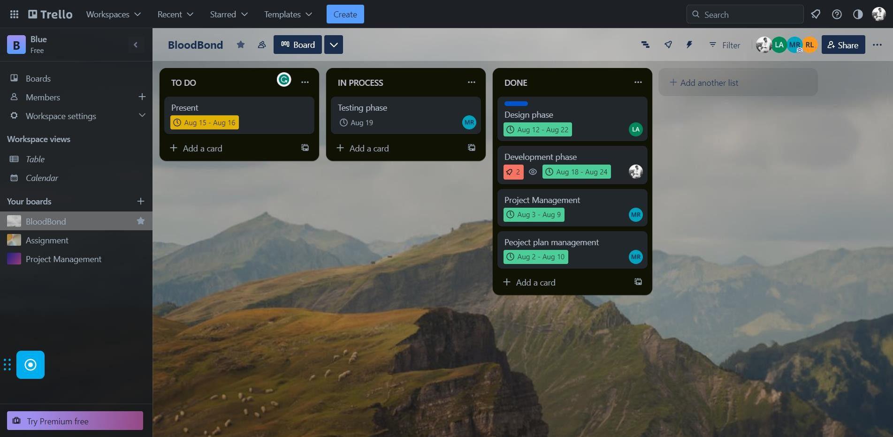

# Resource Estimation:

We will use the following resources for this project:

* Server (3,00,000)
* Computer (2,00,000)
* Internet connection & communication (60,000+ 20,000*8=220,000)
* Tools (70,000)
* Table (65,000)
* Chair (35,000)
* Inter Food (20,000*8=160,000)
* Generator (3,00,000) Total cost is = 850,000

# Time Estimation:

PM: person-month needed for project SLOC: source lines of code

P: project complexity (1.04 – 1.24) DM: duration time in months for project

T: SLOC dependent coefficient (0.32 – 0.38) Software Project

Type Coefficient

<Effort Factor> P T

Organic 2.4 1.05 0.38

Semi-detached 3.0 1.12 0.35

Embedded 3.6 1.20 0.3

Time Estimation: PM: person-month needed for project SLOC: source lines of code P: project complexity (1.03 – 1.14) DM: duration time in months for project T: SLOC dependent coefficient (0.34 – 0.37)

|  |  |  |  |
| --- | --- | --- | --- |
| **Software Project Type** | **Coefficient**  **<Effort Factor>** | **P** | **T** |
| **organic** | **2.4** | **1.05** | **0.38** |
| **Semi-detached** | **3.0** | **1.12** | **0.35** |
| **Embedded** | **3.6** | **1.20** | **0.32** |

Effort = PM = Coefficient*(SLOC/1000) ^P

=2.4*(25000/1000) ^1.05 =70.47 ○ Development time = DM = 2.50*(PM)^T =2.50*(70.47)

^0.38 = 12.59 ~ 13 ○ Required number of people = ST = PM/DM =70.47/12.59 =5.59 ~ 6

# Marketing Plan

## Target Audience:

* Potential blood donors of all ages
* Recipients in need of blood
* Healthcare institutions, hospitals, and clinics
* NGOs and blood banks
* Community leaders and influencers

## Branding and Messaging:

* Brand Identity: Develop a memorable and compassionate brand identity that reflects the platform's mission.
* Key Messaging: Emphasize the power of connectivity, convenience, and compassion in saving lives through blood donation.

## Online Presence:

* Website: Create an informative and user-friendly website detailing the platform's features, benefits, and success stories.
* Social Media: Set up active profiles on popular social media platforms to engage users, share updates, and foster a sense of community.
* Content Strategy: Share educational content, success stories, and engaging visuals to connect with the target audience.

## Public Relations and Media:

* Press Releases: Distribute press releases about significant milestones, partnerships, and impactful stories.
* Media Coverage: Engage with local and national media outlets to cover "Blood Bond" success stories and its role in saving lives.

## Events and Campaigns:

* Blood Donation Drives: Organize and promote community blood donation events in partnership with local organizations.
* Awareness Campaigns: Run awareness campaigns during important health-related observance days (e.g., World Blood Donor Day).

# Cost and Profit Analysis

Cost and profit analysis Total resource cost = 8,50,000 Marketing cost= 40,000

Employee’s salary: 1 project manager = (20,000*10) = 20,0000 5 developers = (30,000*5) *10 = 15,00,000

4 Tester = (15000*4) *10=6,00,000

Total salary cost: (2,00,000+15,00,000 +6,00,000) =23,00,000

Total cost= (8,50,000 + 40,000+23,00,000) =31,90,000

Budget estimation:

Total budget = 31,90,000 ~ 37,60,000

|  |  |
| --- | --- |
| Increased Sales | 24%-30% (Maximum 70%) |
| Improve Customer Service | 95%-100% (24/7) |
| Reduced Inventory Cost | Up to 50% |

# Reference

* Software Requirement Engineering Power Point slide
* Diagram – **Figjam**
* Gantt Chart – **Trello Powerup**
* Project Management Tool – **Trello**
* Project UI - **Figma**